Type Your Title Here
Name Surname^{1*}, Name Surname²

¹ Bandırma Onyedi Eylül University, Faculty of Engineering and Natural Sciences, Transportation Engineering,
Bandırma, Türkiye
² Bandırma Onyedi Eylül University, Faculty of Engineering and Natural Sciences, Transportation Engineering,
Bandırma, Türkiye
*Correspondence
Author 1 ORCID, Author 2 ORCID
Abstract
A concise and factual abstract (200-250 words) should briefly state the purpose of the research, the principal results, and major conclusions. Abstract must be written as one paragraph and abstract must be self-contained, without abbreviations, footnotes, or references.
Keywords: Should be 3 and 6 at least and at most and separated by semicolon.

Introduction
The IEEE citation style should be used [1]. For body text, Calibri 12-point, single-spaced “Normal” font should be used. In this section, the aims of the study should be stated and an adequate literature review should be done. Detailed literature review and summary of results should be avoided. The text should not exceed 15 pages, including all figures, tables and bibliography. All headings should be in bold and numbered consecutively.

Material and method
Information about the materials and methods used in the study should be given in this section. In addition, the tests and analyzes applied to the produced product and/or samples should be explained in this section.

Subheadings
Legible and original figures should be used. Equations should be numbered consecutively throughout the study and positioned right-justified as in Equation (1) below. Figures and tables should be placed at the top or bottom of each page as in Figure 1 and Table 1.

$f\left(x\right)=a_{0}+\sum_{n=1}^{∞}{\left(x_{n}\cos{\frac{abc}{T}}+Y_{n}\sin{\frac{abc}{T}}\right)}$ (1)

Table 1. Table heading
Variables | Values
A | 1
B | 2
C | 3
D | 4

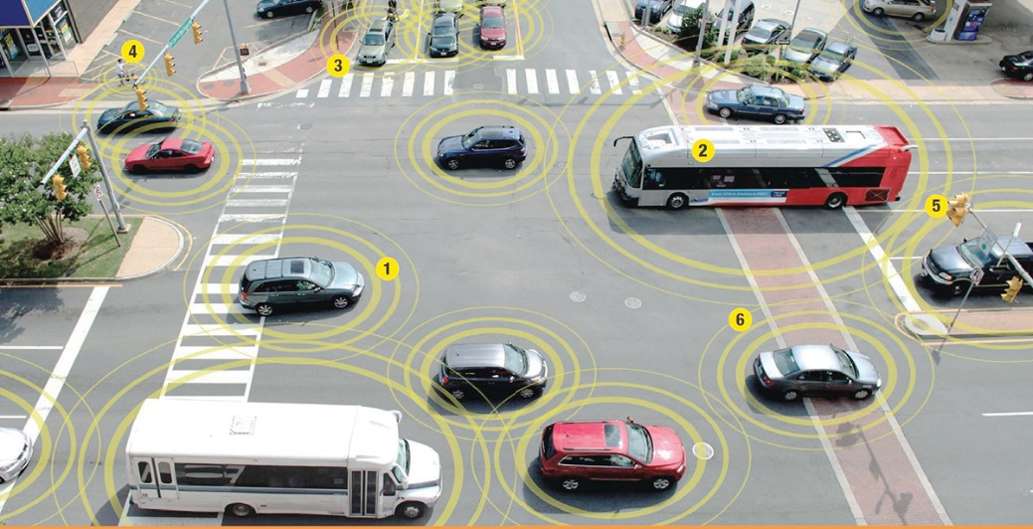
Figure 1. Figure heading

Results and discussion
The results of the study should be presented in this section and the discussions should be addressed here again.

Results
The final evaluation of the entire work should be done in this section.

Acknowledgements
If a statement of conflict of interest or support is not required, this part should not be included in the study. Thesis work, supporting institution, etc. explanations should be made in this section.

Bibliography
[1] “IEEE Reference Guide”. IEEE Periodicals, 2018. [Online]. Accessed via: https://ieeeauthorcenter.ieee.org/wp-content/uploads/IEEE-Reference-Guide.pdf

